REPORT ON MEETING HELD WITH STAKEHOLDERS ON FORMATION OF HIA IMPLEMENTATION COMMITTEE (HIC) UNDER THE GCFRP

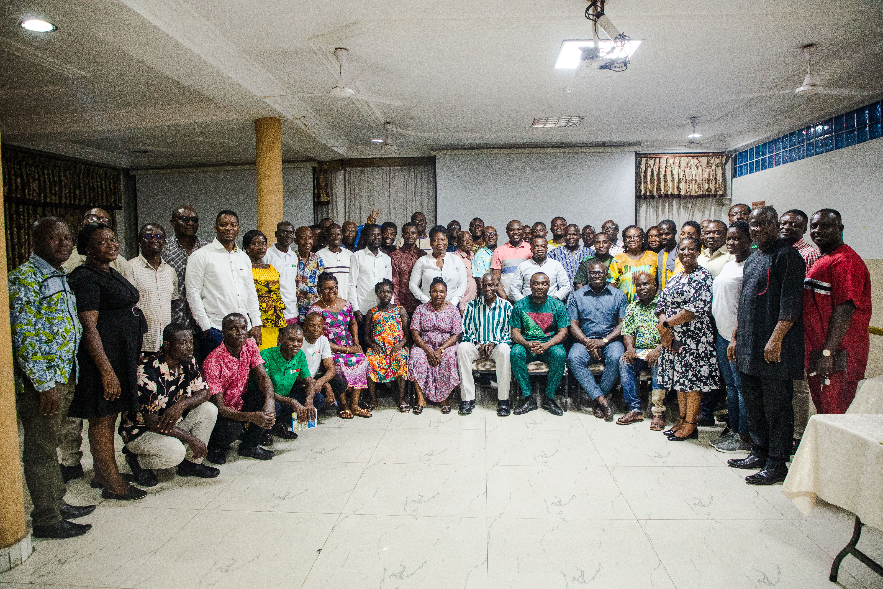

13TH -14TH APRIL 2023,
EJISU-KUMASI

Introduction
Ghana under the Emission Reductions Payment Agreement (ERPA) with the World Bank has received its first carbon payment for the validated and verified reductions in emissions. In line with the Ghana REDD+ Strategy and Benefit Sharing Plan, Ghana intends to effect the distribution of benefits to various beneficiaries including local communities. As such, a key requirement for the disbursement of the carbon payment received through the implementation of the Ghana Cocoa Forest REDD+ Programme (GCFRP) is the formation of the HIA Implementation Committee (HIC). The HIC is an eight-member body made up of three members from the HIA Management Board, three from the consortium partners with Forestry Commission and COCOBOD filling up the remaining two slots. The HIC would serve as the body that supervises the disbursement of the funds to the various beneficiaries identified at the HIA level. In view of the above, on April 13th to 14th, 2023, the National REDD+ Secretariat organized and coordinated a landscape-level workshop which brought together various partners from government, private sector and civil society organizations as wells as local communities (HIA Management Boards). The workshop thus was aimed at facilitating the formation of the HIA Implementation Committees for five out of six HIAs including Asunafo-Asutifi, Ahafo-Ano South, Juaboso-Bia, Kakum and Sefwi Wiawso-Bibiani.
Participation and Institutional representation
Stakeholders present at the workshop included HMB representatives from the Asunafo Asutifi, Kakum, Juaboso-Bia, Sefwi Wiawso-Bibiani-Akontombra, and Ahafo Ano HIAs, FC (Regional and District Forest Managers, Wildlife Division), COCOBOD (Cocoa Health and Extension Division), Civil Society Organizations (e.g., Tropenbos Ghana, Emergent Climate, EcoCare Ghana, Solidaridad, Rainforest Alliance, Proforest, SNV), Touton, Cargill, Mondelez, World Cocoa Foundation (WCF).

Context Setting and Opening Statements by the National REDD+ Secretariat
Mr Gyambrah (Manager, Programmes and MRV) on behalf of the Chief Executive and the Director, Climate Change, welcomed all participants and expressed his excitement for the impressive turn up. According to him the workshop formed part of the key processes that would enable the disbursement of carbon funds to the landscape-level beneficiaries. He explained that the first payment received from the World Bank is one of the many payments Ghana stand a chance of benefiting from if all and sundry put their hands on deck in the course of further reducing emissions from deforestation and forest degradation. He therefore enjoined all partners to do their part to enable the programme succeed in terms of delivering the reduction of 10m tons and thus, enable Ghana to rake in all the $ 50 m signed under the Emission Reduction Payment Agreement (ERPA). Mr Gyambrah pointed out that the different stakeholder groups present would enable the fair and balanced of representation of stakeholders in the formation of the HICs as stipulated in the Benefit Sharing Plans. He brought to the attention of all participants that Kakum HIA had already formed their HIC and as such, there was no need to reinvent the wheel although the Kakum experience would be useful in guiding the HIC formation for the remaining HIAs.

ADDRESS BY SOME KEY PARTNERS
Mr. Michael Amoah on behalf of COCOBOD expressed his enthusiasm to be part of the program. In his remarks, he stressed on the strong collaboration between COCOBOD and the Forestry Commission through the GCFRP. He indicated that COCOBOD’s new strategic document aims to increase trees cover on cocoa farms which aligns with the objectives of the GCFRP. He used the opportunity to encourage the local actors particularly cocoa farmers to take advantage of GCFRP to improve their livelihoods while reducing emissions from deforestation.
In the same vein, the Director of Tropenbos Ghana (Mercy Owusu Ansah), thanked all stakeholders for their role and long stay history with the REDD+ process. She urged the local communities to manage their expectations so far as the farmer and community benefits are concerned. She added that the successful implementation of the BSP processes and Fund Flow Mechanism largely depends on their understanding, commitment and cooperation. She added that communities in the various landscapes should select members who are transparent, accountable and trustworthy to represent them on the HIA Implementation Committee.
The convener and cofounder of EcoCare Ghana (Mr Obed Addai) similarly expressed his appreciation and commended the proponent of the program for integrating local communities on the HIA implementation committee. He indicated that this disposition would afford local communities to obtain first-hand information and also directly share their views and perspectives during HIC decisions. He concluded that the selection and nomination of the local communities (HMB) should be guided by the principles of fairness and inclusivity.
Partners including Trobenbos Ghana, Cocobod and Ecocare encouraged all participants to actively participate to ensure the successful implementation of the program.

PRESENTATION ON HIC
The National REDD+ Secretariat led a presentation on the Fund Flow Mechanism which details the processes through REDD+ funds shall flow from the national level (thus, from the RDA Steering Committee) to the landscape level. The NRS reiterated that key precondition for the release of funds from the national is the submission of proposals indicating the in principle what the funds will be used. Hence, the HICs of the respective HIAs will help in drafting the proposals for the respective HIAs and that importance of having the HICs in place cannot be overestimated. The NRS again apprised the participants through the designed procurement processes that guides the procurement of goods and services that would be procured under the programme. According to the NRS, the BSP operational manual prescribes that all members of the bodies of the FFM, inter alia, the RDA Committee of Trustees, the HIA Implementation Committee, the HIA Management Board, the Sub-HIA Executive Committee and the CREMA Executive Committee (“FFM officers”) shall in all their activities and performance of their roles and responsibilities in the sharing of benefits from the ER payment be governed and guided by the following principles of good governance: transparency, local content, accountability, integrity, Transparency & Conflicts of Interest and Efficiency & Effectiveness.

In summary, the presentation of NRS focused on the following:
- Governance Arrangements under the Ghana Cocoa Forest REDD+ Programme;
- The role of the RDA Committee of Trustees;
- The role of the HIA Management Board (HMB);
- Processes for selection of Consortium Partner(s) for Procurement/Contracting;
- Criteria for Selecting (a) member(s) of the Consortium for Procurement or Contracting;
- Procurement & Contracting Processes
  - Terms and conditions for Procurement
  - Delivery of Benefits to Farmer Groups
  - Delivery of Benefits to the Community; and
- Responsibilities of Procurement Entities.
The Roles of the HIA IMPLEMENTING COMMITTEE (HIC)
)

- Send to RDA Trustees all HIA reports and documentation
- Manage disbursement of Carbon Fund payments received from the RDA
- Oversee entire procurement and execution of project
  - HIC responsible for selecting Consortium Partners to procure and distribute CSC items and execute community development projects
- Issue Purchase Orders
- Make sure funds are available and enough to keep project within budget
- Checking/inspecting and confirming items and confirming successfully delivered and distribution, requesting and archiving all statutory documents from vendors e.g. GRA tax clearance certificates
- Issue resolution to authorize HMB to pay for successfully executed procurement
- Recording keeping/archiving of all documentation for HIA (for audit purposes and provide support to the Ministry of Finance and the RDA Committee of Trustees-led process for the annual auditing of HIA account

- RDA Trustees or HMB must be signed by them)
- Monitoring and reporting of benefit-sharing activities
- Monitoring of the HIA stakeholder indicators
- Receive information from all HIA bodies
- Database: Details of all beneficiaries in HIA including SHECs, CECs, CREMAs, communities and farmer groups in the HIA
- Shortlist of community development proposals
- List of CSC inputs agreed to by registered farmer groups, HMB and Consortium
- Review all proposals against selection criteria and ESMP (Environmental and Social Management Plan)
- Feedback on functioning of FFM and other benefit-sharing related matters
- Receive proposals/applications for community development projects from SHEC

QUESTIONS AND ANSWERS
Q & A ON THE HIC PRESENTATION
Question | Response
The formation of the HIC was initially six (6) and it has been changed to eight (8). Why? | This has become necessary to ensure equitable representation of all key stakeholders on the HIC.
Will the HMB select all the 8 members of the HIC | No, the HMBs have three slots on the HIC.
Will the subsequent carbon payments delay like the initial one? | Lessons learned from the initial process would help speed up subsequent payments processes.

HIC Formation and HIC Maiden Meeting
For each of the HIA, the HIC was formed with representatives of the local communities, Forestry Commission, Ghana Cocoa Board, Civil Society Organization and the private sector. Following the formation of the HICs, the HICs kickstarted their maiden committee meeting to discuss and work on the requests submitted by the HMBs on behalf of the local communities. Specifically, the HICs deliberated on the prioritized farmer benefits and arrived at a decision with justification for the selected items and indicative budgets for each priority item. Prior to the workshop, the NRS had collated the various farmer requests from the various HIAs and thus, submitted the request templates for the actions of the respective HICs. This enabled the HICs to have something to work. The HICs were to later submit the report of their meetings to the NRS through their respective designate contact persons.
Key Lessons
- This heightened awareness on BSP processes to wider stakeholder group.
- Greater appreciation of the fund flow process.
- The is existing governance arrangement and/or structures available to facilitate the equitable, inclusive and transparent transfer of benefits to beneficiaries.
- Considerable consultations and engagements by proponents
- The process is very participatory as various partners are engaged and involved in the process: civil society, government, private sector and local communities
- Consideranble capacity building effected
- Roles of partner and implementer clearly defined

Conclustion

NEXT STEPS
The meeting settled on the following key next steps:
- The various HICs were encouraged to come up with their proposal and share it with the NRS for onward submission to the RDA.
- Participants were informed that WhatsApp platforms would be created for the various HICs to enhance communication

